Type-C Female to MicroUSB Male Charge & Sync Conversion Adapter

Charge and Sync your MicroUSB connected

AndroidTM Smarphone or Tablet using existing Type-C cables
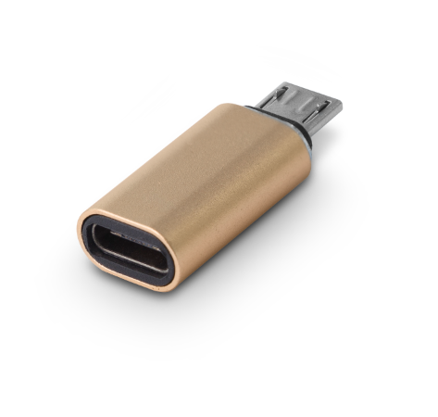
C-TC-MIC

Descrption:
Need to charge or data sync your AndroidTM powered smartphone, tablet or other MicroUSB interfaced portable device?

Simply plug our adapter into your device's MicroUSB port and connect your existing USB-C cable for not only charging your AndroidTM device but also syncing data to its host computer.

Compact and stylish with a durable aluminum alloy construction that's totally Plug n' Play for your AndroidTM digital devices and other compatible MicroUSB devices too.

SPECIFICATIONS
- Type-C to Micro USB
- Connector:Micro male/type-c female
- support data transfer
- material:aluminum alloy
- pruduct size:29.1x11.6x6.91mm

Product Code:
- Part number: C-TC-MIC
- Product net weight: 3g
- Barcode: 8400800036728

